### 实战三 HTML+CSS基础实战

#### 一、实验目的

能利用HTML及CSS基本知识，完成指定页面设计。

#### 实验内容和要求

1. 运用HTML和CSS，制作如下登录界面。(提示，可以通过border-radius属性，实现圆角边框)

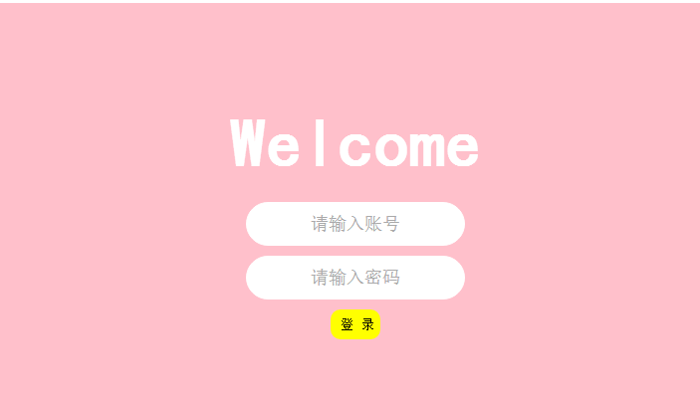

效果图1

<!DOCTYPE html>

<html>

    <head>

        <meta charset="UTF-8">

        <title>用户登录</title>

        <link rel="stylesheet" type="text/css" href="./css/t3_1.css"/>

    </head>

    <body>

        <div class="context">

            <div class="container">

                <h1>Welcome</h1>

                <form action="" method="get">

                    <input type="text"  name="userid" placeholder="请输入账号"/>

                    <input type="password"  name="userpw" placeholder="请输入密码"/>

                    <button type="submit">登  陆</button>

                </form>

            </div>

        </div>

    </body>

</html>

* {

margin: 0;

padding: 0;

}

/*去掉页面样式，通用选择器*/

body {

background-color: #FFC0CB;

}

h1{

font-weight: bolder;

color: #FFFFFF;

}

/*标签选择器*/

.context {

background: #FFC0CB;

position: absolute;

left: 0;

top: 50%;

width: 100%;

height: 400px;

margin-top: -200px;

overflow: hidden;

/*隐藏滚动条*/

}

/*定位浏览器边距位置 左 上 */

.container {

/*类选择器*/

max-width: 600px;

height: 400px;

/*左右*/

padding: 80px 0;

/*上下*/

text-align: center;

margin: 0 auto;

/*居中显示*/

}

.container h1 {

/*派生*/

font-size: 40px;

font-weight: 300;

}

form {

padding: 20px 0;

}

form input {

border: 1px solid #FFF;

width: 220px;

padding: 10px 15px;

display: block;

margin: 0 auto 10px auto;

border-radius: 30px;

/*圆角*/

font-size: 18px;

font-weight: 300;

text-align: center;

}

form button {

background: yellow;

border: 0;

padding: 10px 15px;

color: black;

border-radius: 8px;

width: 50px;

font-size: 10px;

text-align: center;

font-weight: bold;

}

form button:hover {

background: #CCC;

/*鼠标移动上去按钮颜色变灰色*/

}

1. 制作如图所示百度首页，要求运用CSS设置对应格式，灵活运用盒子模型。

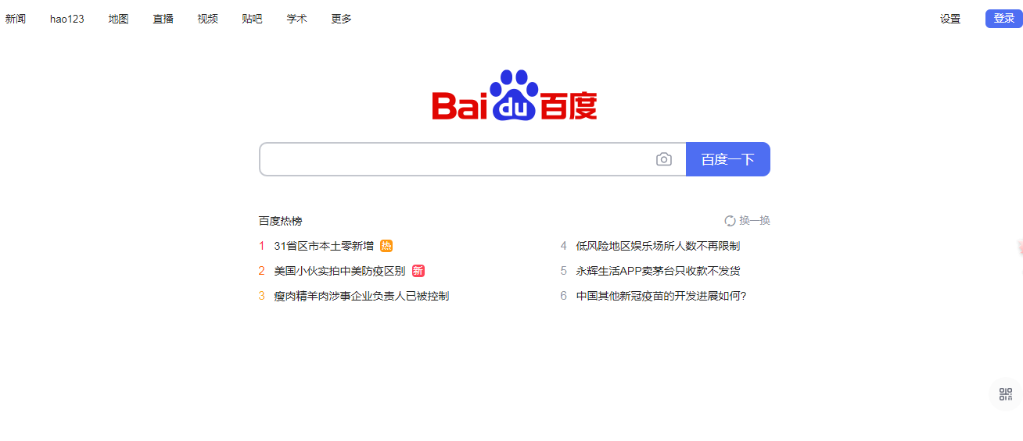

效果图2

<!DOCTYPE html>

<html>

<head>

<meta charset="utf-8">

<title>百度一下，你就知道</title>

<link rel="stylesheet" type="text/css" href="./css/h2.css" />

</head>

<body>

<div class="baidu">

<div class="head1">

<a class="mav" href="http://news.baidu.com">新闻</a>

<a class="mav" href="http://www.hao123.com">hao123</a>

<a class="mav" href="http://map.baidu.com">地图</a>

<a class="mav" href="http://v.baidu.com">视频</a>

<a class="mav" href="http://tieba.baidu.com">贴吧</a>

<a class="mav" href="http://xueshu.baidu.com">学术</a>

<a class="mav" href="https://passport.baidu.com/v2/?login&tpl=mn&u=http%3A%2F%2Fwww.baidu.com%2F">更多</a>

</div>

<div class="head">

<a class="mav" href="http://www.baidu.com/gaoji/preferences.html">设置</a>

<a class="gen" href="http://www.baidu.com/more/" style="display: block;">登陆</a>

</div>

<div class="centers">

<div class="imgs">

<img src="./img/logo1.png" width="270" height="129">

</div>

<span class="sone">

<input type="text" name="" class="sou" maxlength="255">

</span>

<span>

<input class="btn" type="submit" value="百度一下">

</span>

</div>

<center>

<div style="width: 600px;">

<table border="0" cellspacing="10" cellpadding="10" width="800" style="margin-top: 50px;">

<tr>

<td>百度热搜</td>

<td></td>

<td></td>

<td style="text-align: end;">换一换</td>

</tr>

<tr>

<td>

<font size="3" color="red" style="font-weight: bold;">1</font>

</td>

<td>31省区市新增确诊6例均为境外输入</td>

<td>

<font size="3" color="grey" style="font-weight: bold;">4</font>

</td>

<td>经历冷静期后武汉6成夫妻放弃离婚</td>

</tr>

<tr>

<td>

<font size="3" color="darkorange" style="font-weight: bold;">2</font>

</td>

<td>警方通报打捞出疑似西藏冒险王尸体</td>

<td>

<font size="3" color="grey" style="font-weight: bold;">5</font>

</td>

<td>俄罗斯召回驻美大使</td>

</tr>

<tr>

<td>

<font size="3" color="orange" style="font-weight: bold;">3</font>

</td>

<td>英首相:对中国进行新冷战是错的</td>

<td>

<font size="3" color="grey" style="font-weight: bold;">6</font>

</td>

<td>2020年十大健康谣言</td>

</tr>

</table>

</div>

</center>

<div class="tail">

<div class="one"></div>

<div class="two">

<img src="./img/logo2.png" width="80" height="86">

</div>

<div class="thr">

<p id="lh">

<a href="//www.baidu.com/cache/sethelp/help.html" target="_blank">把百度设为主页</a>

<a href="http://home.baidu.com">关于百度</a>

<a href="http://ir.baidu.com">About  Baidu</a>

<a href="http://e.baidu.com/?refer=888">百度推广</a>

</p>

<p id="cp">

©2017 Baidu <a href="http://www.baidu.com/duty/">使用百度前必读</a> <a href="http://jianyi.baidu.com/"

class="cp-feedback">意见反馈</a> 京ICP证030173号 <i></i> <a target="_blank"

href="http://www.beian.gov.cn/portal/registerSystemInfo?recordcode=11000002000001">京公网安备11000002000001号</a> <i></i>

</p>

</div>

</div>

</div>

</body>

</html>

.head {

color: #fff;

position: absolute;

right: 0;

top: 0;

margin: 19px 0 5px;

padding: 0 96px 0 0;

}

.head1 {

color: #fff;

position: absolute;

left: 0;

top: 0;

margin: 19px 0 5px;

padding: 0 96px 0 0;

}

.mav {

float: left;

color: #333;

font-weight: 700;

line-height: 24px;

margin-left: 20px;

font-size: 13px;

text-decoration: underline;

}

.head a:hover {

color: #00c

}

.centers {

text-align: center;

}

.gen {

position: absolute;

right: 10px;

width: 60px;

height: 23px;

float: left;

color: #fff;

background: #3385ff;

line-height: 24px;

font-size: 13px;

text-align: center;

border-bottom: 1px solid #38f;

margin-left: 19px;

text-decoration: none

}

.imgs {

margin-top: 30px

}

.sone {

border: 1px solid #b6b6b6;

background: #fff;

display: inline-block;

vertical-align: top;

width: 539px;

height: 34px;

border-color: #b8b8b8 #ccc #ccc #b8b8b8;

overflow: hidden;

}

span {

margin: 0;

padding: 0

}

input {

border: 0;

padding: 0;

}

.sn {

height: 16px;

width: 18px;

}

.sou {

width: 526px;

height: 22px;

font: 16px/18px arial;

line-height: 18px;

margin: 6px 0 0 7px;

padding: 0;

outline: 0;

}

.btn {

width: 100px;

height: 36px;

color: #fff;

font-size: 15px;

letter-spacing: 1px;

background: #3385ff;

}

.tail {

text-align: center;

}

.one {

height: 191.5px;

}

p,

p>a {

color: #999;

line-height: 22px;

font: 12px arial;

}

#lh a {

margin-right: 12px;

}

i {

width: 14px;

height: 17px;

display: inline-block;

}